**API Documentation**

* **For Client-side**

First run npm install which will automatically install all the dependencies.

Since the website is in development mode so it will run on localhost:3000 with **npm start.** Open <http://localhost:3000> to view it in the browser. Try running the browser with clearing the cookies.

* **For Server-side**

Move inside the server directory and run **node index.js** which runs on port 5000

1. **Facebook Sign Up**

**Getting Started:**

Initializing the Facebook api requires appID which you can get after creating app on Facebook developer account site( <https://developers.facebook.com> ).

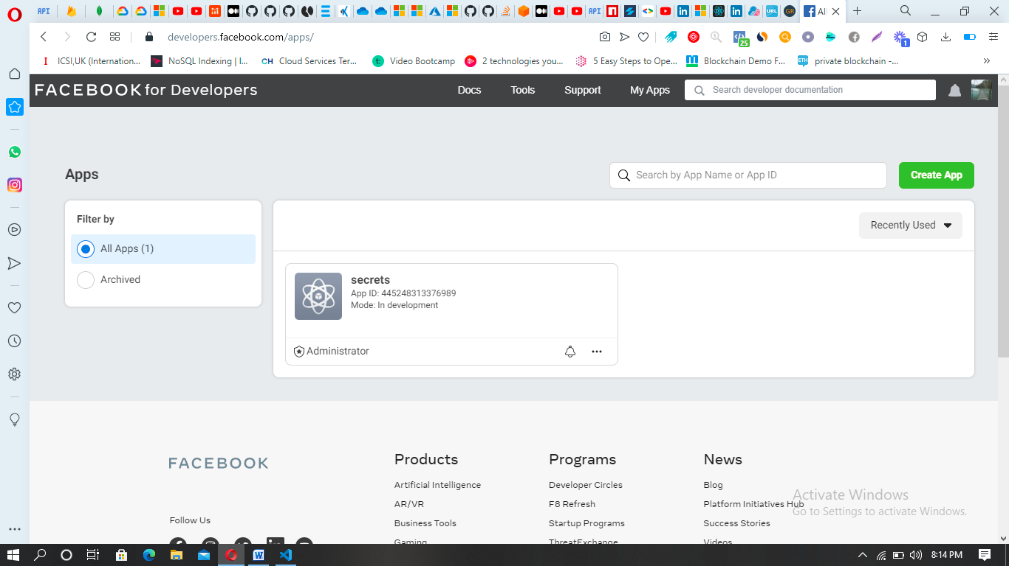

On clicking the Facebook Sign up Button, the login status will be checked against the request. On finding it as connected, it will fetch the profile of the user and post it to backend and stored on MongoDb. After a user logs in a pop-up Modal appears in which further details can be added.

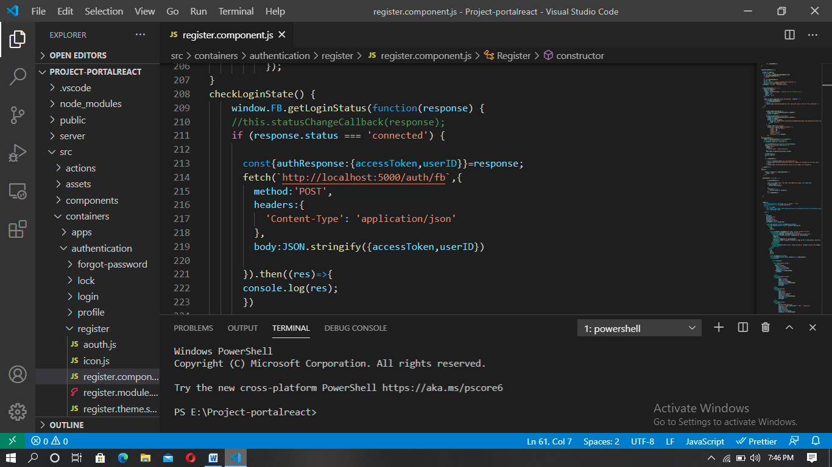

1. **Google Sign Up**

**Getting Started:**

We will need pairs of CLIENT_ID and CLIENT_SECRET for every provider to implement authentication on the front-end and the back-end.

To use Google, we need to create a project in [Google Developer Console](https://console.developers.google.com/), go to the credentials tab and add OAuth 2.0 Client.

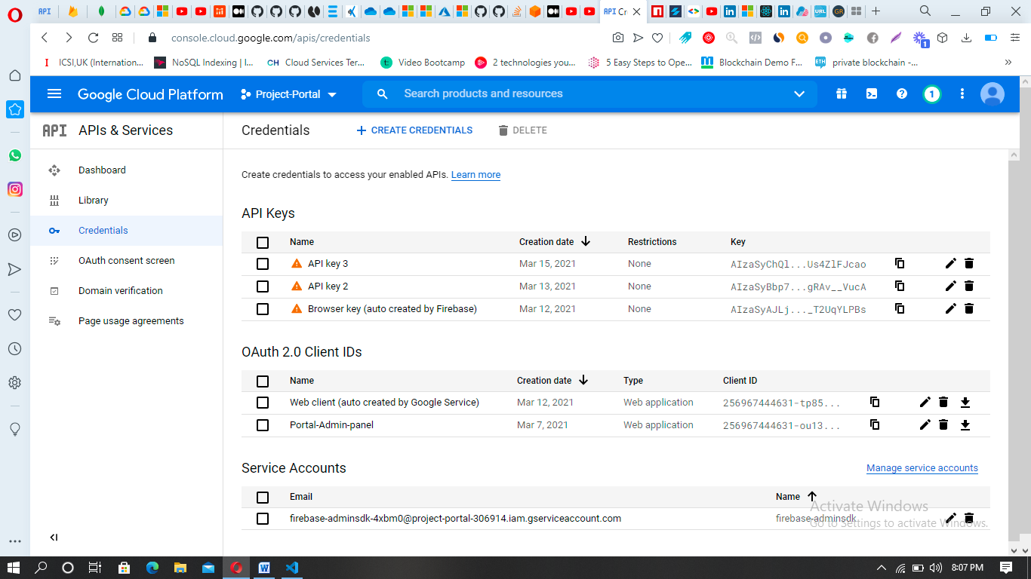

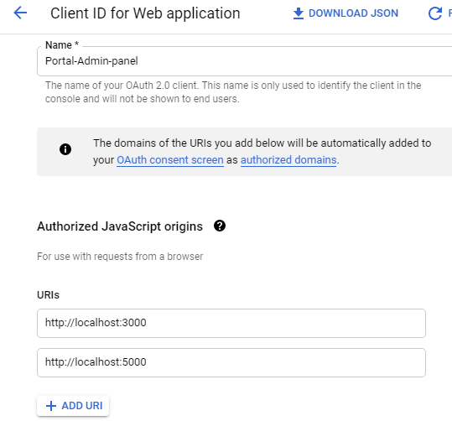

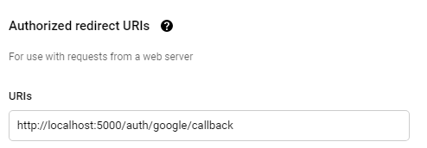

On clicking the Google Login Button, the login status will be checked against the request. It will fetch the profile of the user and post it to backend and stored on MongoDb. After a user logs in a pop-up Modal appears in which further details can be added.

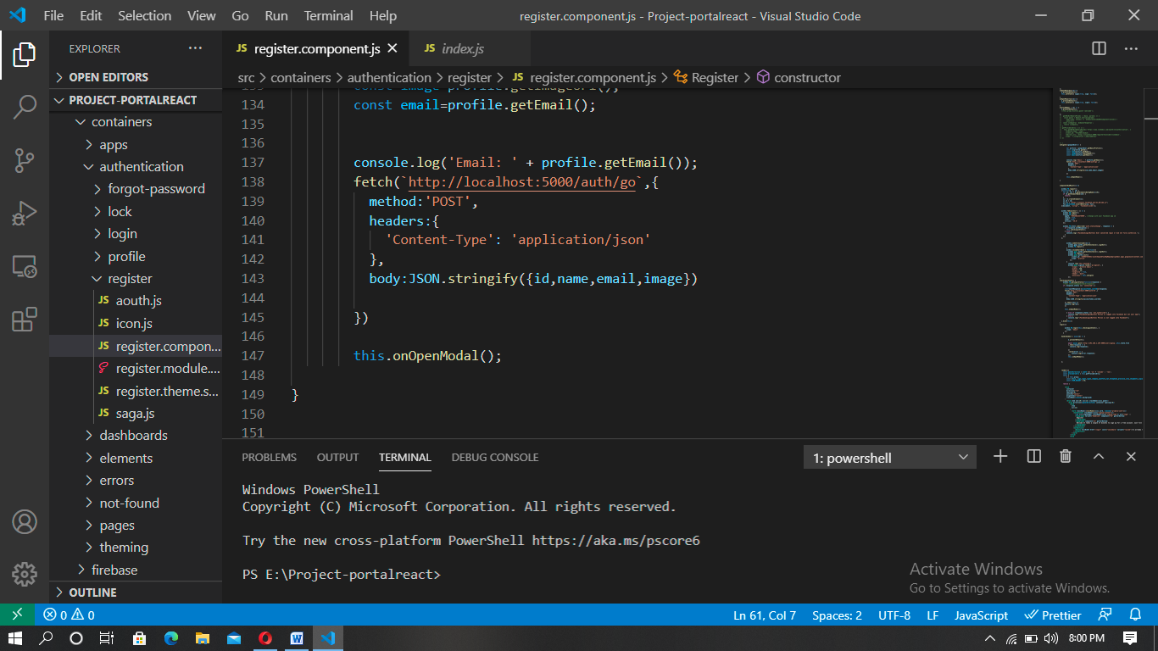

1. **Manual Sign Up**

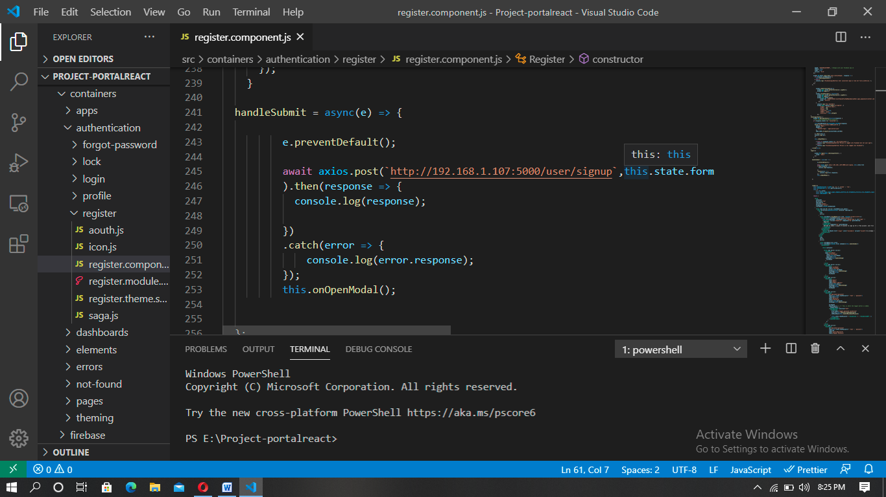

**Client side execution for Facebook, Google and Manual Signup :**

In server folder for connectivity with Mongodb a connection string is required which you receive after making a cluster on Mongodb. Place that string within the connection_string parameter in index.js file. Two routes were made one for manual sign up which goes to ‘user’ route and the other for social login with is ‘auth’. In the routes simple functions of adding new user to mongodb is done. Since the social logins already have security ensured thus for manual sign up jsonwebtokens and bcrypt libraries are used.